Milestone 1

Joshua Ruiz

CST – 117

March 7, 2021

**GitHub:**

**https://github.com/jdruiz854/CST-117/tree/InventorySystem**

**Part 1**

**Data Model**

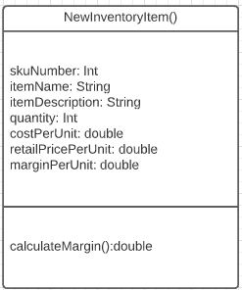

**Part 2**

**Low Resolution Form**

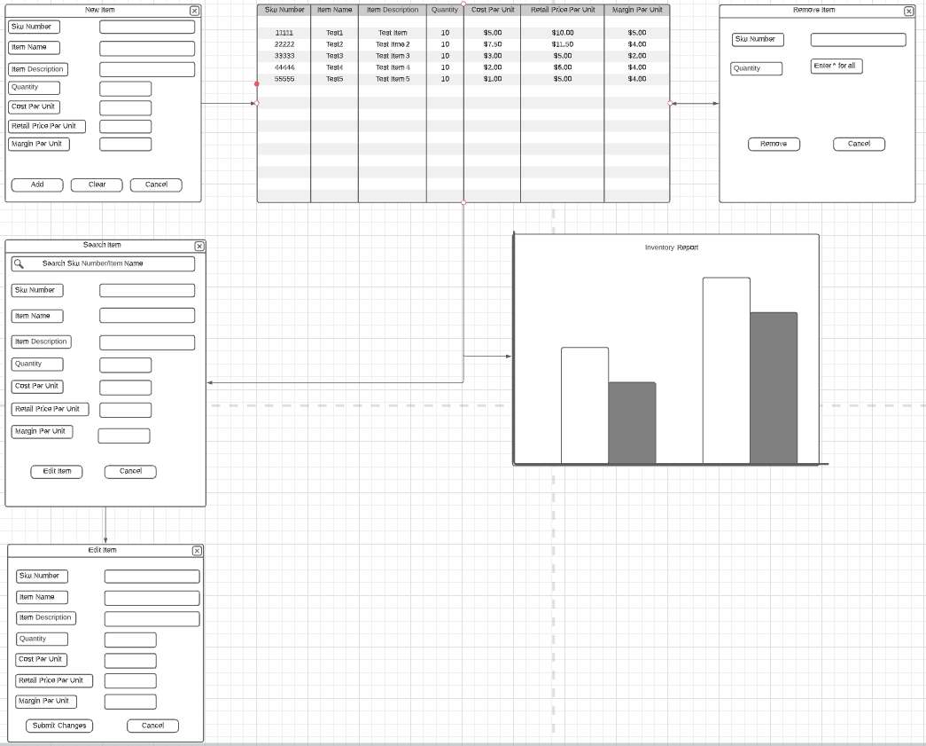

**Part 3**

**High Resolution Form**

